**DAILY ONLINE ACTIVITIES SUMMARY**

|  |  |  |  |  |  |  |  |  |
| --- | --- | --- | --- | --- | --- | --- | --- | --- |
| **Date:** | **20-05-2020** | | | | | **Name:** | **Raksha** | |
| **Sem & Sec** | **6th B** | | | | | **USN:** | **4AL17CS073** | |
| **Online Test Summary** | | | | | | | | |
| **Subject** | | **System software and compiler design (SSCD)** | | | | | | |
| **Max. Marks** | | **30** | | **Score** | | | **21** | |
| **Certification Course Summary** | | | | | | | | |
| **Course** | **FullStack Webdevelopment & CyberSecurity specialisation** | | | | | | | |
| **Certificate Provider** | | | **Greatlearning**  **udemy** | | **Duration** | | | **45 days**  **35days** |
| **Coding Challenges** | | | | | | | | |
| Problem Statement: 1. Write a Java Program which illustrates how to get column properties from ResultSet using ResultSetMetaData?  ResultSetMetaData is an object that can be used to get information about the types and properties of the columns in a ResultSet object. Below example shows how to get ResultSet column properties using ResultSetMetaData object.  2. Write a C Program to Reverse a Linked List in groups of given size. | | | | | | | | |
| **Status:** YES, Completed all Programs | | | | | | | | |
| **Uploaded the report in Github** | | | | | **YES** | | | |
| **If yes Repository name** | | | | | https://github.com/raksha05/[Daily-Status](https://github.com/raksha05/Daily-Status)/[Raksha 4AL17CS073](https://github.com/raksha05/Daily-Status/tree/master/Raksha%204AL17CS073)/**Raksha** | | | |
| **Uploaded the report in slack** | | | | | **YES** | | | |

Online Test Details: (Attach the snapshot and briefly write the report for the same)

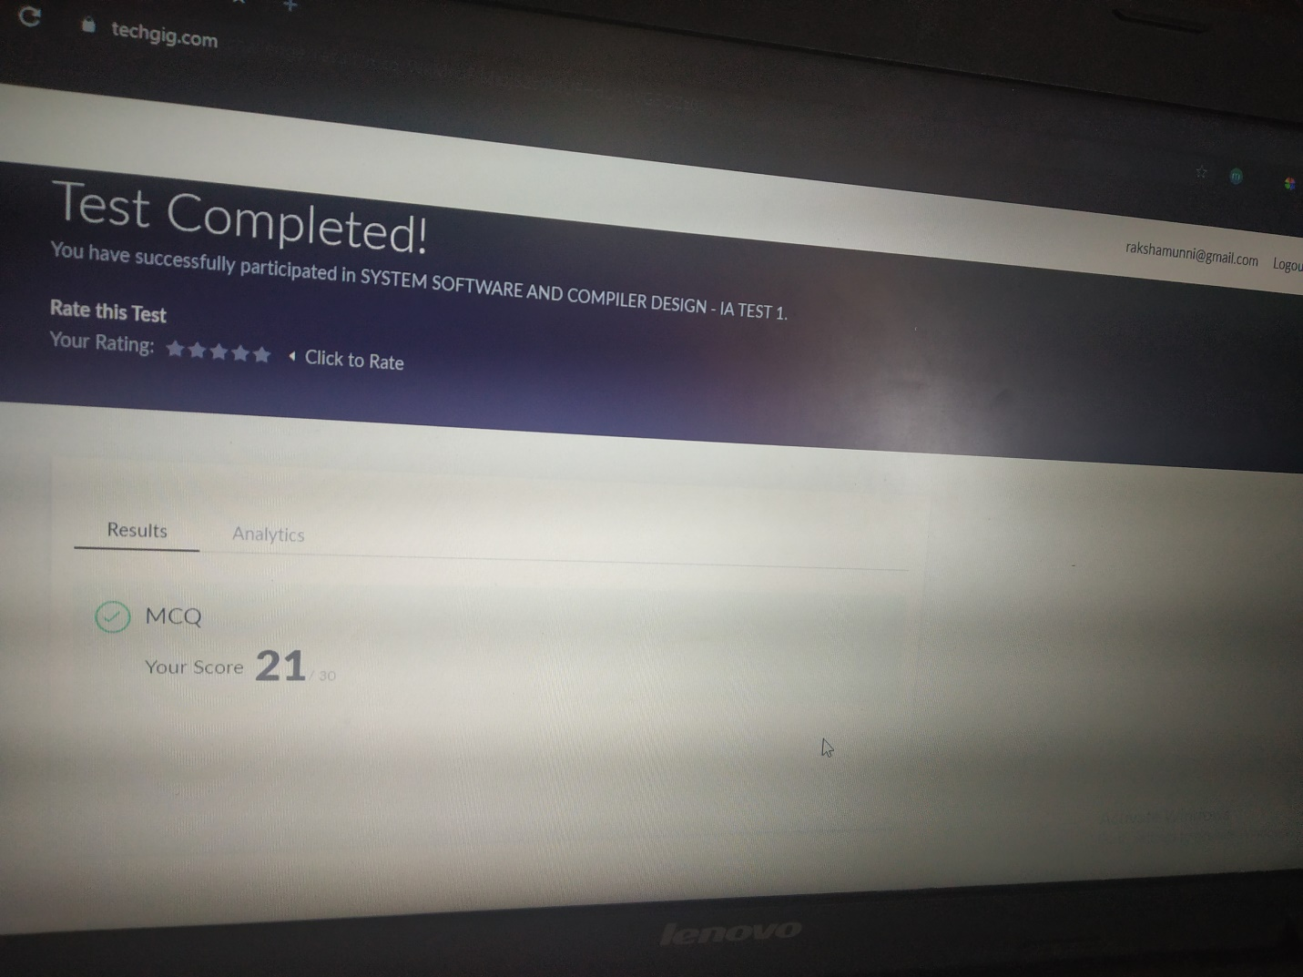

Scored 21 out of 30 in SSCD 1st I.A test

Certification Course Details: (Attach the snapshot and briefly write the report for the same)

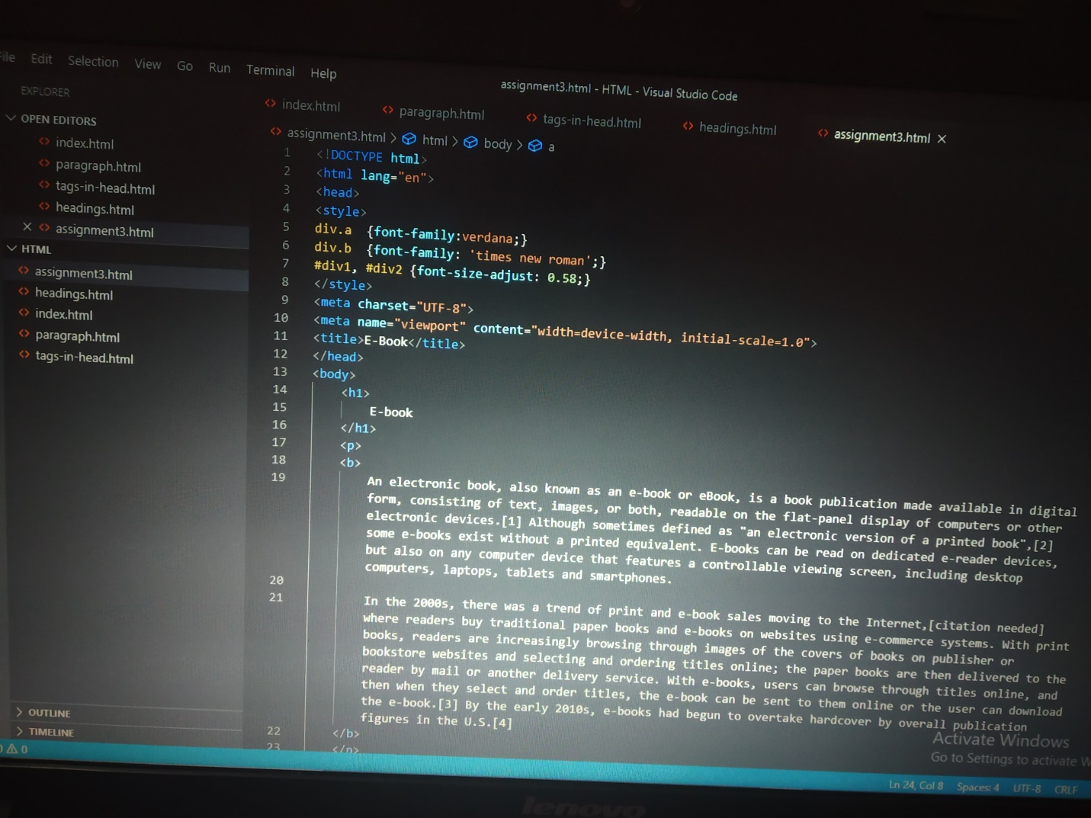

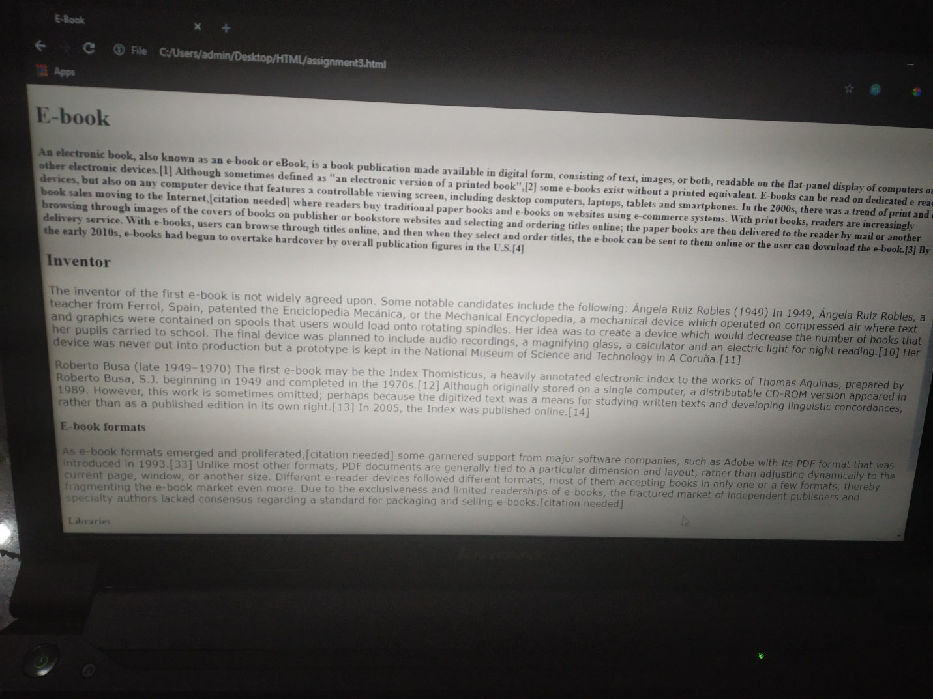

The above course is being taken up by me is based on FullStack webdevelopment. It started with the html tags, today in online course I studied about the types of header tags.the above was the assignment given to me create a webpage of E-book and to use different header tags for different sections .And I learnt how to modify the font size using CSS font size styles.

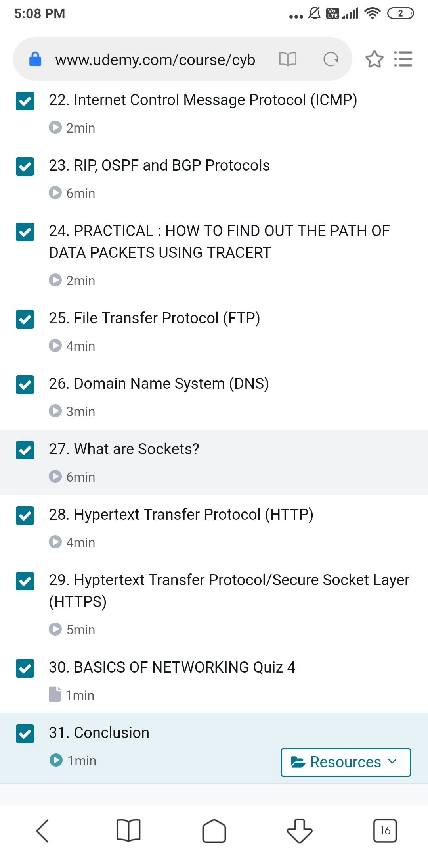

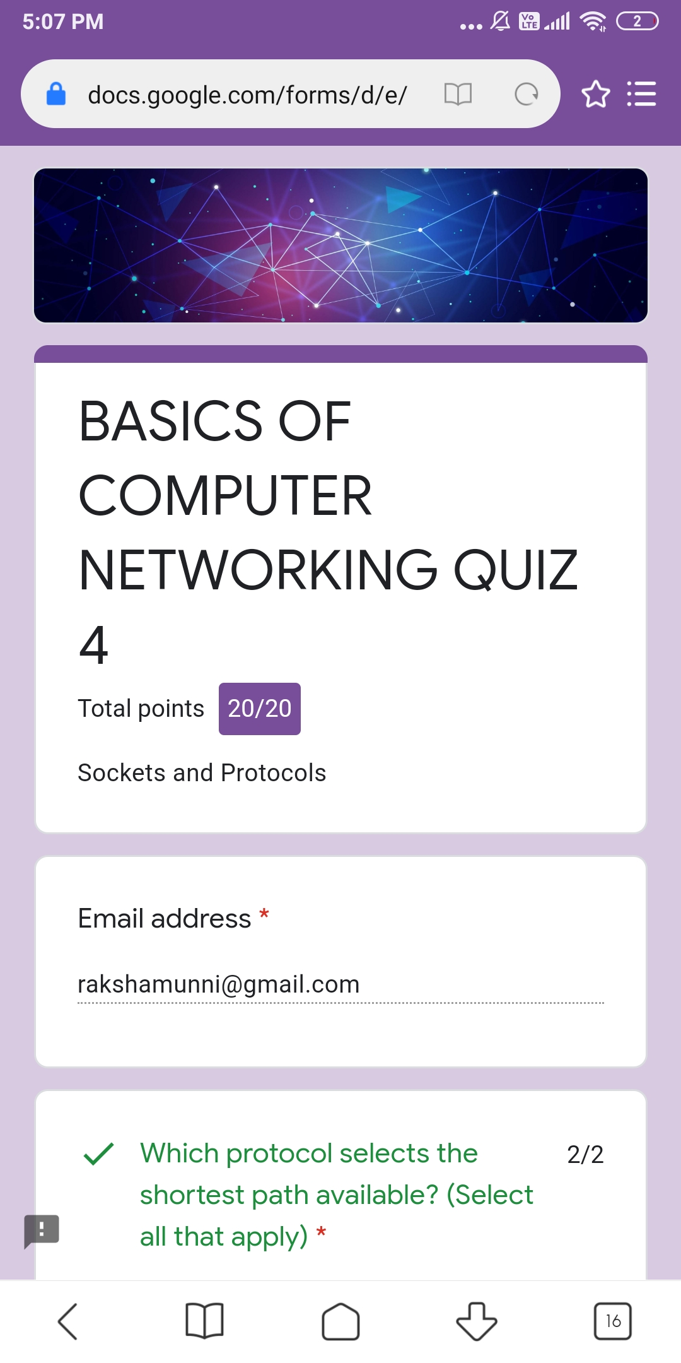

The above course is taken by me CyberSecurity Specialization where it starts from section of basics of networking where I learnt today different protocols and its uses.About HTTP & HTTPS uses and applications.Today I completed section 1 about basics of networking and assignment test was given where I scored 20 out of 20.

Coding Challenges Details: (Attach the snapshot and briefly write the report for the same)

Program1:

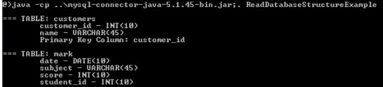

Program2:

